From Palaces to Peace
GOLDEN TRIANGLE & ANANDA WELLNESS RETREAT
India’s most famous wellness retreat

Delhi – Jaipur – Agra – Rishikesh
13 Nights – 14 Day

s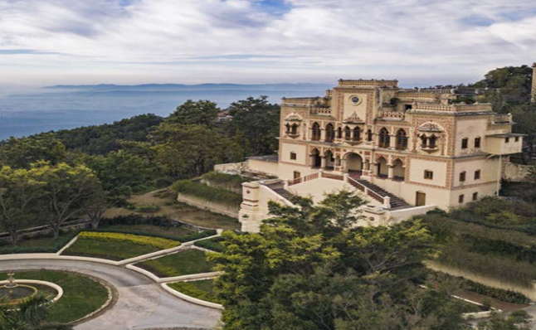 

“Restore your center, refresh your soul”

Experience India's iconic wonders and profound tranquility with our exclusive 'Golden Triangle & Himalayan Wellness' package. This journey combines rich cultural exploration through Delhi, Jaipur, and Agra with a rejuvenating 7-day immersive wellness stay at Ananda in the Himalayas. Discover holistic healing, personalized yoga, and Ayurvedic therapies amidst serene Himalayan vistas for complete rejuvenation.

Ananda in the Himalayas is an elite wellness destination designed to renew body and soul. Combining ancient Ayurvedic wisdom, daily yoga, and holistic healing, it is a haven for restoring balance and energy. With a focus on natural healing, healthy cuisine, and mental tranquility, it offers a complete, rejuvenating escape.

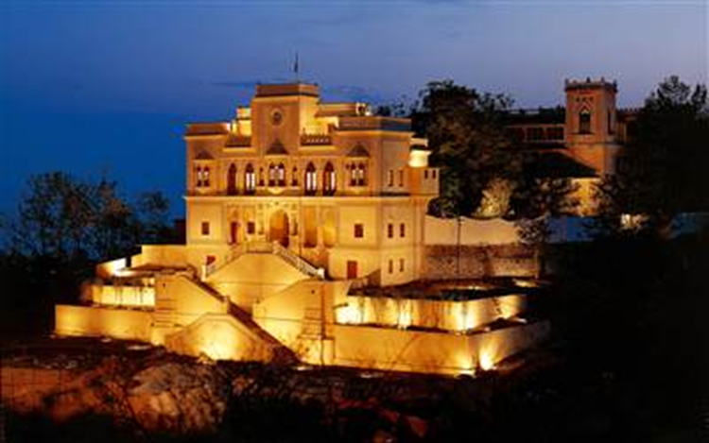

Ananda is a sanctuary of ancient Indian practices, offering Ayurveda. This practice revitalizes the body and spirit. A consultation that confirmed an individual's constitution and tailored their treatment was the highlight of this experience.



ITINERARY

Day 01 – Arrival in Delhi
Arrival at Delhi International Airport. After completing immigration formalities and collecting baggage, you will be met at the Arrivals Terminal and transferred to your hotel.
Hotel check-in upon arrival (standard check-in time: 14:00).
Delhi, the capital of India, is the main gateway to the country. Modern Delhi is a bustling metropolis that blends ancient heritage with contemporary life. Amid towering skyscrapers stand historic monuments that silently reflect the region’s rich past. The first impression during the airport transfer reveals a garden-like city surrounded by trees and beautiful parks.
In the evening, we attend an Aarti ceremony to receive blessings for health, peace, and a positive beginning to our journey.
In Indian culture, every new journey or project begins with an Aarti ceremony and the application of a tika—a sacred mark on the forehead made from colored powder, kumkum, or sandalwood paste.
Overnight:Delhi
Meals: Breakfast

Day 02 – New Delhi
Breakfast at the hotel.
Morning exploration of Old Delhi, visiting key historical and cultural landmarks. Visit Raj Ghat, the memorial dedicated to Mahatma Gandhi. Continue through the Rashtrapati Bhavan area, home to major government buildings and the national parliament, and pass by India Gate, an iconic symbol of British-era architecture. Visit the Salt March Memorial and Connaught Place, the commercial heart of the city.
Later, visit the Sikh temple Bangla Sahib, a place of peace and spiritual connection. Conclude the day at Swaminarayan Akshardham Temple, the largest Hindu temple complex in the world.
Overnight:Delhi
Meals: Breakfast

Day 03 – New Delhi to Jaipur (256 km)
Breakfast buffet at the hotel. Drive to Jaipur. During the journey, guests may interact freely with the guide to learn more about Indian culture, traditions, rituals, and history.
Jaipur, the capital of Rajasthan, is a romantic land of grand palaces, mighty forts, and royal maharajas, set on the edge of the western desert. Known as the Pink City, Jaipur was painted pink in 1856 to welcome Prince Albert during his state visit. Arrival in Jaipur, hotel check-in, and rest.
Overnight:Jaipur
Meals: Breakfast

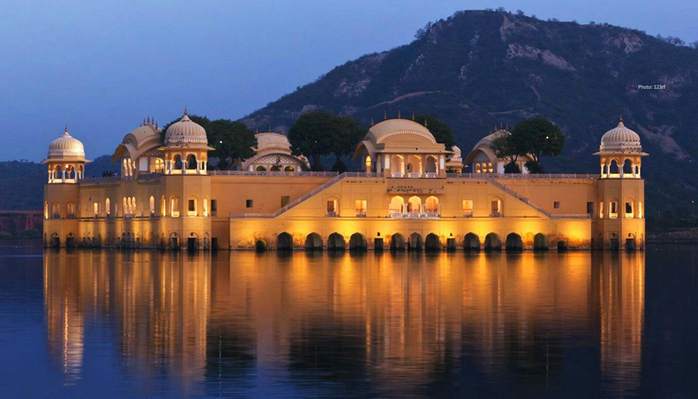

Day 04 – Jaipur – Amber – Jaipur

Breakfast buffet at the hotel.
Morning participation in a Hawan ceremony, a Hindu fire ritual performed to attract positive energy and cleanse negative influences.
Visit Amber Fort, explore the palace complex including Jag Mandir, Jai Mahal, and the Kali Temple with its gardens. Built in 1592 by Raja Man Singh I and completed by Jai Singh I, Amber Fort showcases a magnificent blend of Mughal and Hindu architecture. An optional elephant or jeep ride may be available for the ascent to the fort (subject to regulations).
In the afternoon, explore local markets and visit textile workshops producing traditional Jaipur designs. Later, attend the Aarti ceremony at Birla Temple, followed by a traditional dinner with folk dances of Jaipur.
Overnight: Jaipur
Meals: Breakfast

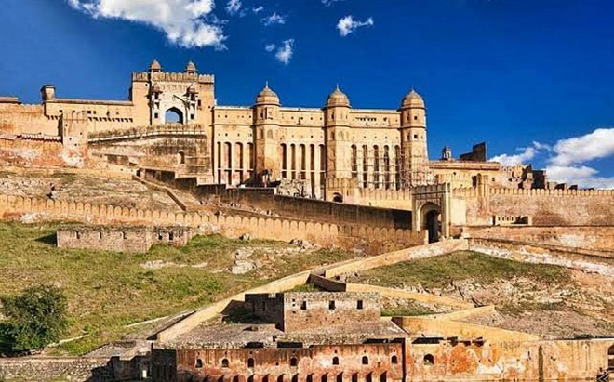

Day 05 – Jaipur – Abhaneri – Agra (236 km)

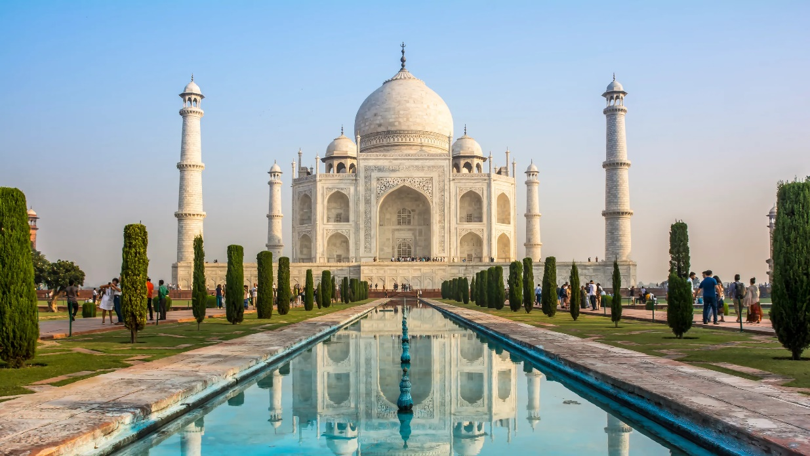

Breakfast buffet at the hotel.
Drive to Agra,
In the afternoon, visit the Taj Mahal (closed on Fridays), a timeless monument of love built by Emperor Shah Jahan in memory of his wife Mumtaz Mahal. Constructed over 22 years, this white-marble masterpiece is one of the Seven Wonders of the World.
Hotel check-in upon arrival.
Overnight:Agra
Meals: Breakfast

Day 06 - Agra – Rishikesh (By Road)
After an early breakfast, drive to Rishikesh (approx. 5 hours), known as the world capital of yoga. Upon arrival, visit the iconic Beatles Ashram, renowned for its rich and fascinating history. Later, experience the mesmerizing Ganga Aarti ceremony on the banks of the holy River Ganga (approx. 2 hours). Thereafter, proceed to Ananda Spa Resort for check-in and relaxation.
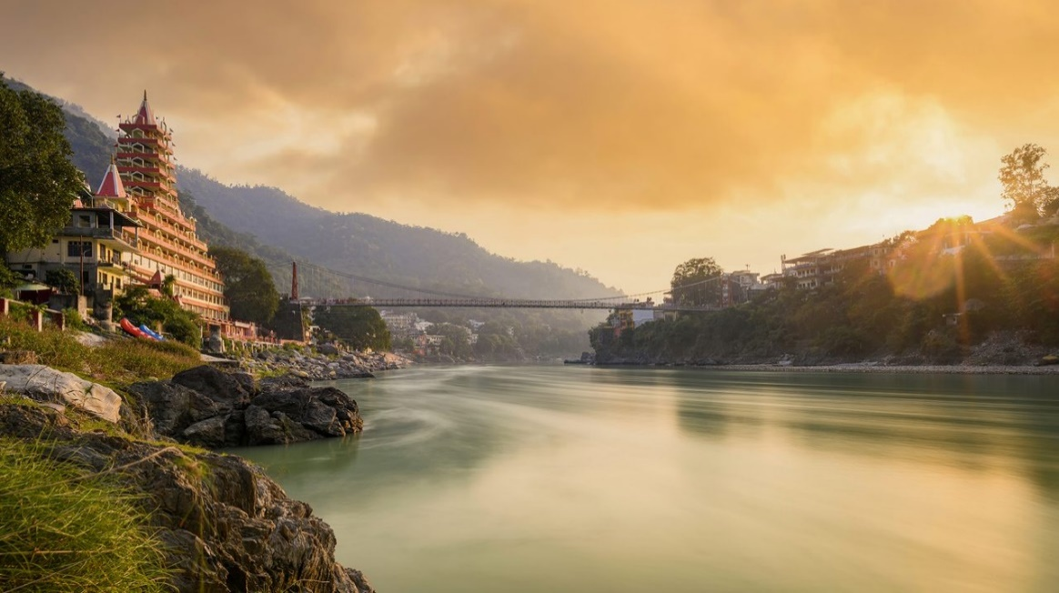

Day 7 - 14 Ananda Wellness Retreat


This package includes a 7-night stay at Ananda in the Himalayas, featuring the Comprehensive Wellness Program that you can choose. Each program requires a 7-nights minimum stay. If you wish to choose a longer program, or extend your stay, extra nights can be added on a pro-rated basis.
During your stay, you are welcome to join Ananda’s group activities: yoga, meditation, fitness classes, Vedanta talks, cooking classes and treks. All of which are complimentary and conducted in small groups.
Comprehensive wellness program (starting 7 nights) – These are immersive programs to address proactive health goals, ongoing lifestyle issues, and moderate disorders. These programs include continuous wellness consultations with experts prior to arrival, during the program and post departure to guide and monitor progress and achieve wellness goals. These programs include therapies combined with personal sessions of yoga, meditation, fitness, and other wellness practices. On average, Comprehensive Wellness Programs include 2 hours of wellness sessions daily. Rate for all programs under Comprehensive Wellness is the same.

1.- Detox & Cleansing:
- Holistic Detox (7 Nights – 14 Nights - 21 Nights)
- Yogic Detox (7 Nights – 14 Nights - 21 Nights)
- Panchakarma (21 Nights)
2.- Immunity & Vitality
- Ayurvedic Rejuvenation (7 Nights – 14 Nights - 21 Nights)
- Renew (7 Nights – 14 Nights - 21 Nights)
- Holistic Yoga (7 Nights – 14 Nights - 21 Nights)
3.- Mental Health & Spiritual Balance
- Stress Management (7 Nights – 14 Nights - 21 Nights)
- Dhyana Meditation (7 Nights – 14 Nights - 21 Nights)
- Sleep Enhancement (7 Nights – 14 Nights - 21 Nights)

4.- Fitness & Weight Management
- Weight Management (14 Nights – 21 Nights)
- Activ-Fitness (7 Nights – 14 Nights - 21 Nights)
5.- Hormonal Disorders
- Diabetes Management (14 Nights - 21 Nights)
- Hormonal Rebalance (7 Nights – 14 Nights - 21 Nights)
- Menstrual Health (14 Nights - 21 Nights)
- Fertility Enhancement (14 Nights - 21 Nights)
6.- Chronic Ailments
- Pain Management (7 Nights – 14 Nights - 21 Nights)

Days 14– Rishikesh – Delhi
After breakfast, transfer to Delhi by road. Upon arrival in Delhi, proceed to Terminal 3 for your international connection back home.

HOTELS

- Delhi: Park Plaza Shahdara or similar (2 nights)
- Jaipur: Sarovar Premiere or similar (2 nights)
- Agra: Royal Sarovar or similar (1 night)
- Rishikesh: Vasundhara Palace or similar (1 night) + Ananda Wellness Center (7 nights)

INCLUDED

- Airport assistance and transfers.
- Private air-conditioned vehicle with driver.
- The first 6-night accommodation with breakfast as per itinerary, then 7 nights with all meals in Ananda Wellness Center.
- 7 days Comprehensive Wellness Program + Activities: yoga, meditation, fitness classes, Vedanta talks, cooking classes and treks.
- All entrance fees.
- English speaking guide during excursions mentioned above.
- Daily bottled mineral water.
- Rickshaw ride in Old Delhi
- One traditional dinner with cultural dances.
- Hindu cooking class and village visit.
- All applicable taxes and tolls

NOT INCLUDED

- Beverages not mentioned
- Excess baggage charges
- Tips and porterage
- Personal expenses
- Costs arising from cancellations or circumstances beyond the operator’s control

IMPORTANT NOTES

- Taj Mahal closed on Fridays
- Red Fort and Akshardham Temple closed on Mondays
- Boat rides subject to river conditions
- Hotels subject to availability
- Check-in 14:00 / Check-out 12:00
- Travel times are approximate and not guaranteed.
- Hotel check-in: 14:00 | Check-out: 12:00
- Early check-in subject to availability
- Prices subject to currency fluctuations and fuel surcharges

“Conclude your journey with renewed body, mind, and spirit”.



